**Graphical User Interface (GUI)**

Graphical User Interface allows the users to interact with the application through web pages and the android device using icons and some visual notations. TalkBack provides a very user-friendly interface that can be easily and smoothly operated by all professors and students, thereby, improving the classroom experience on the whole.

The GUI for TalkBack is shown below:

**Server End Application**

**Initial Login Page for Admin**

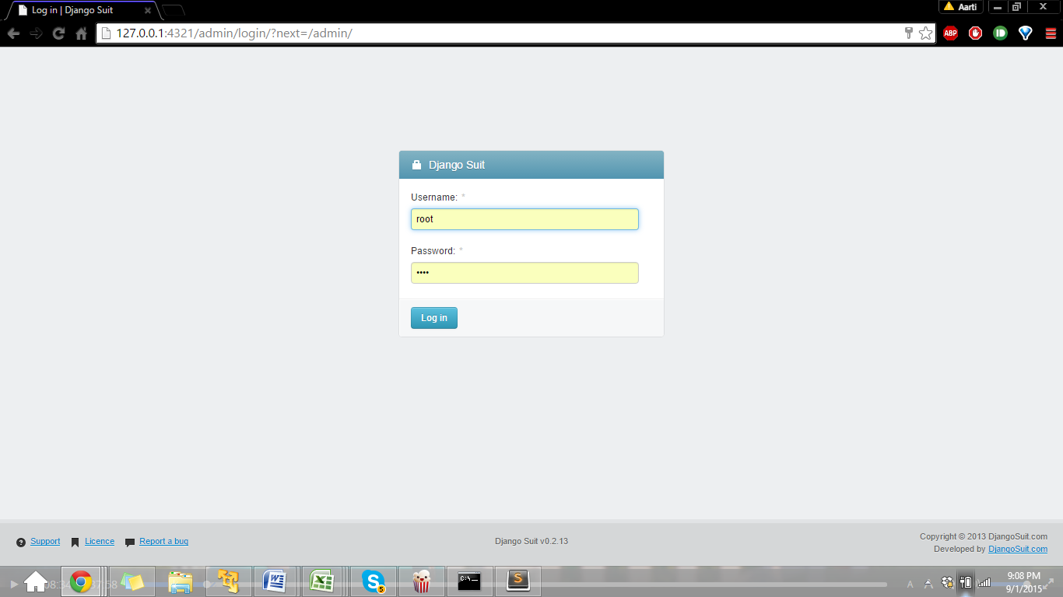

**Home Page at Admin-end**

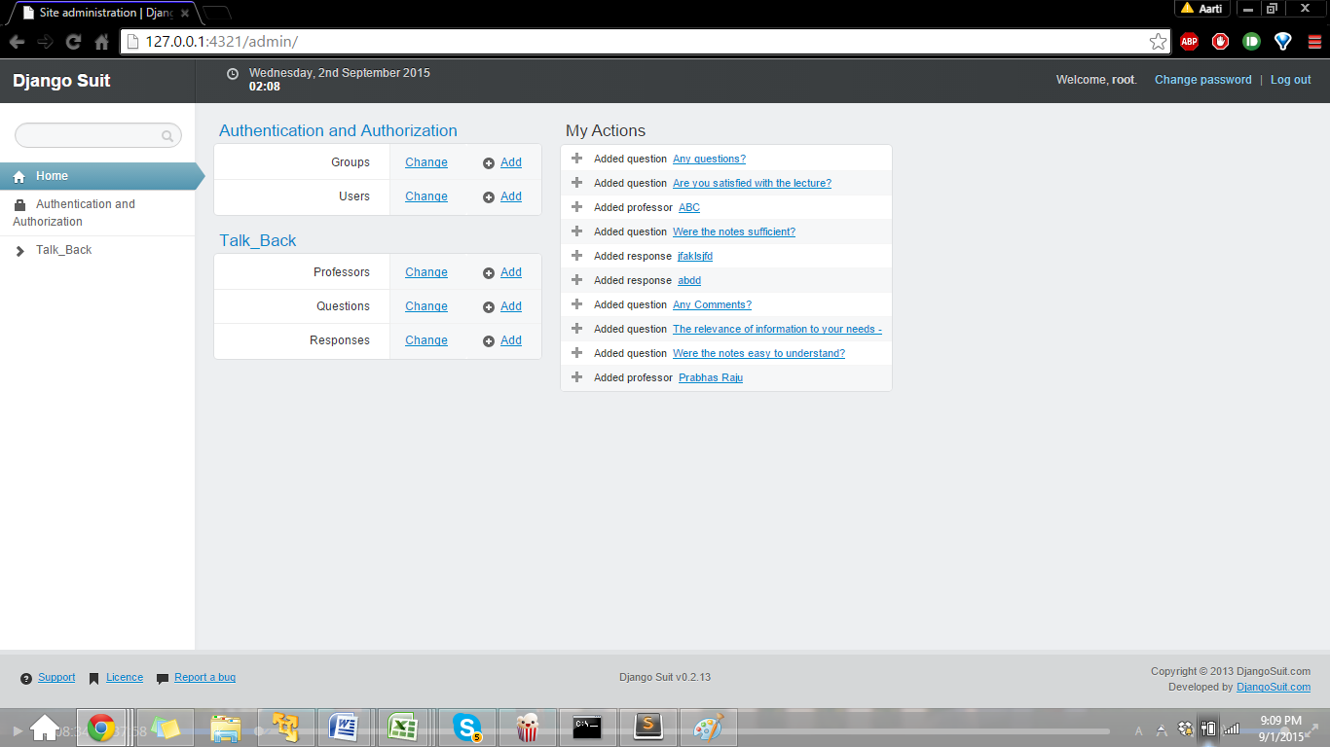

**Adding Professors**

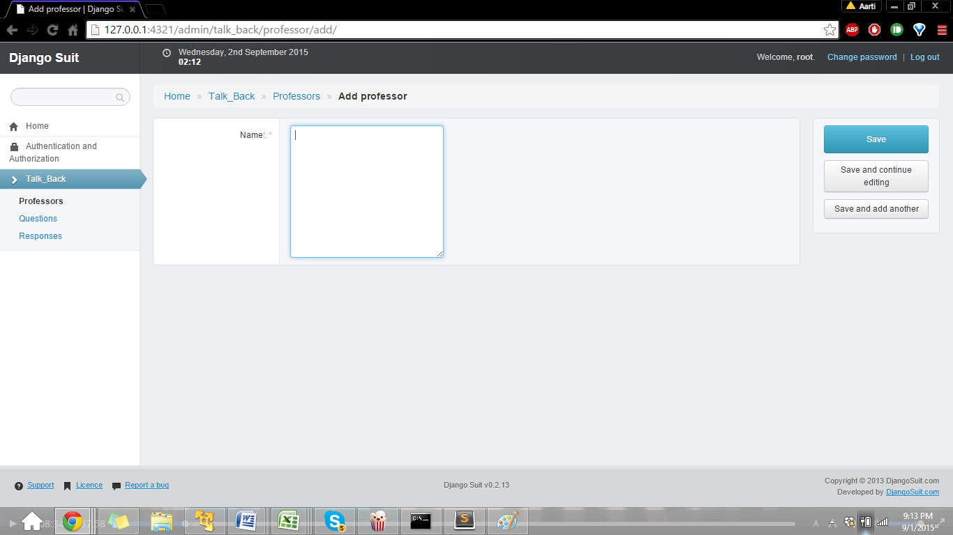

**Professors Table**

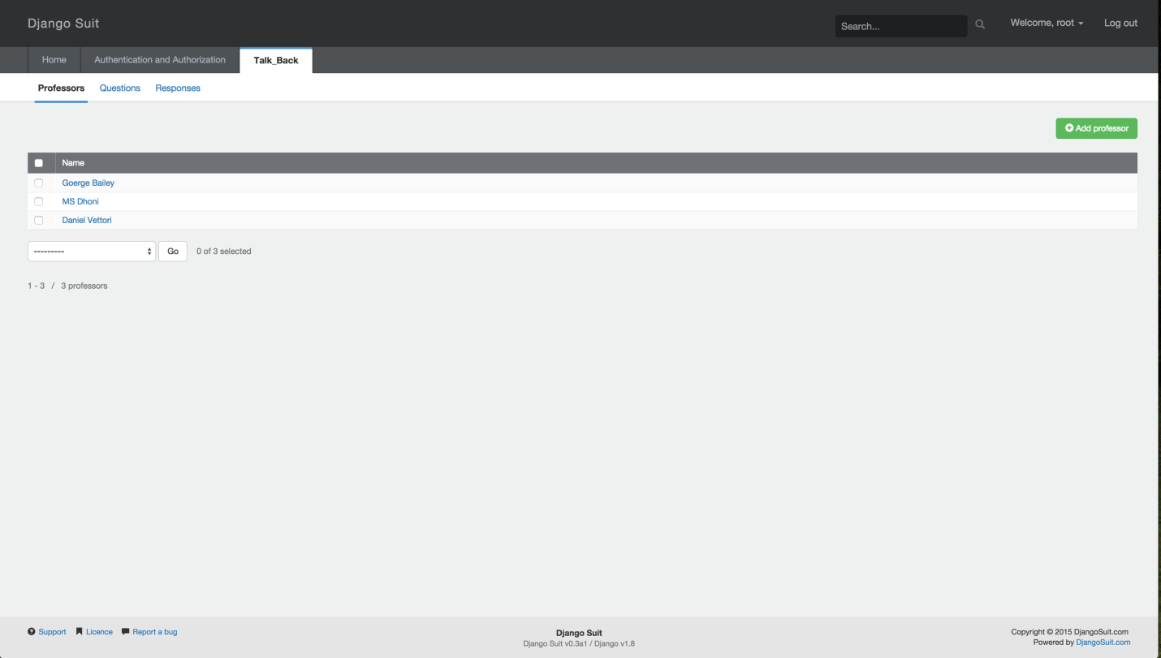

**Adding a Question**

**1. Yes/No Questions:**

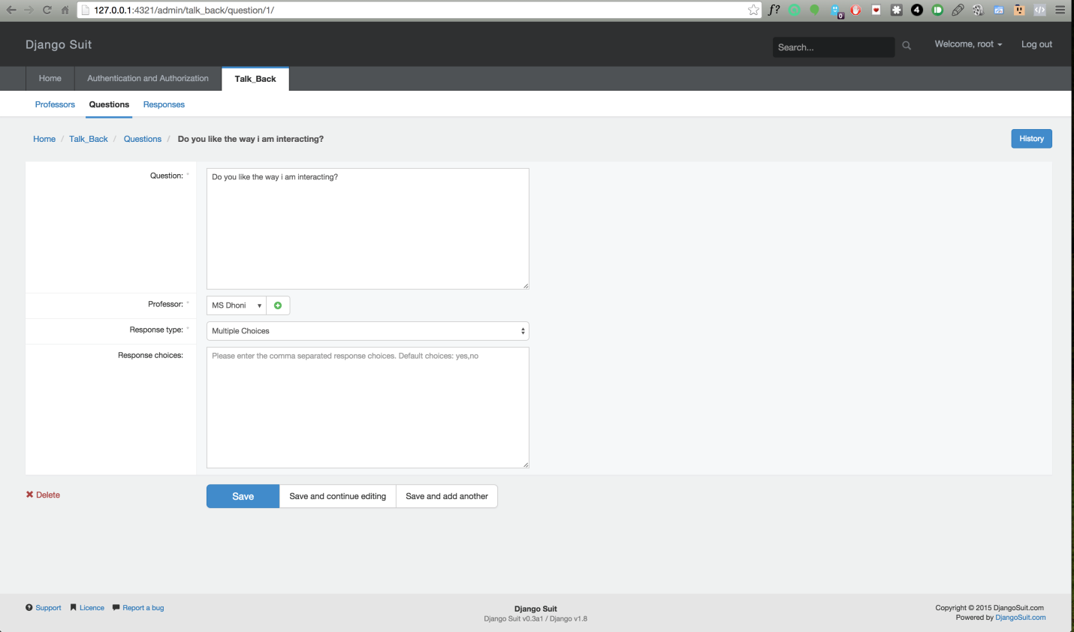

**2. Multiple Choice Questions:**

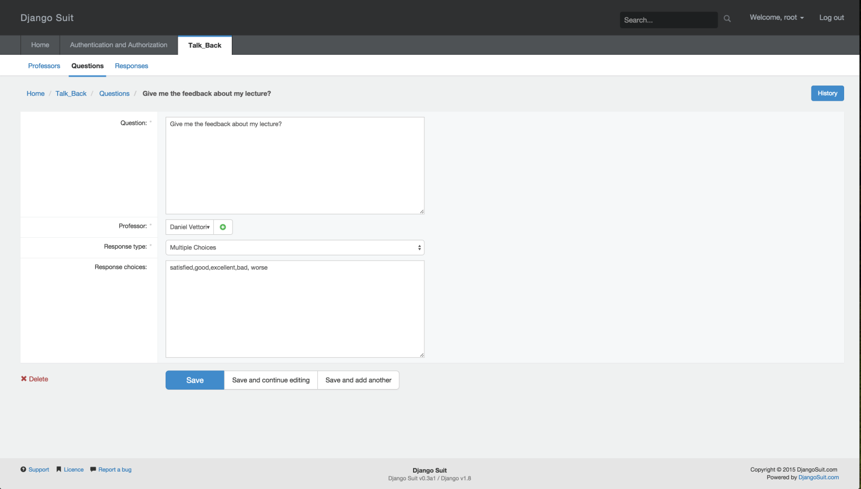

**3. Descriptive Text Questions:**

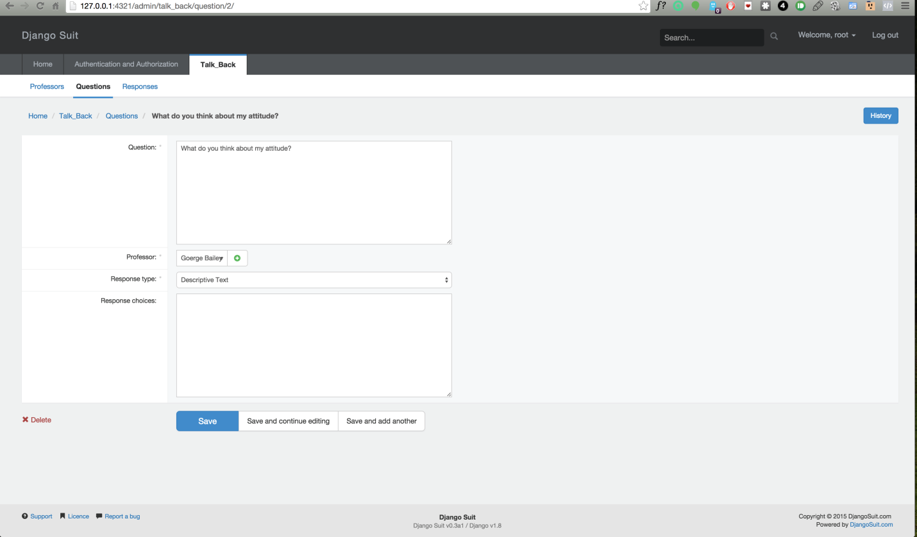

**Questions Table**

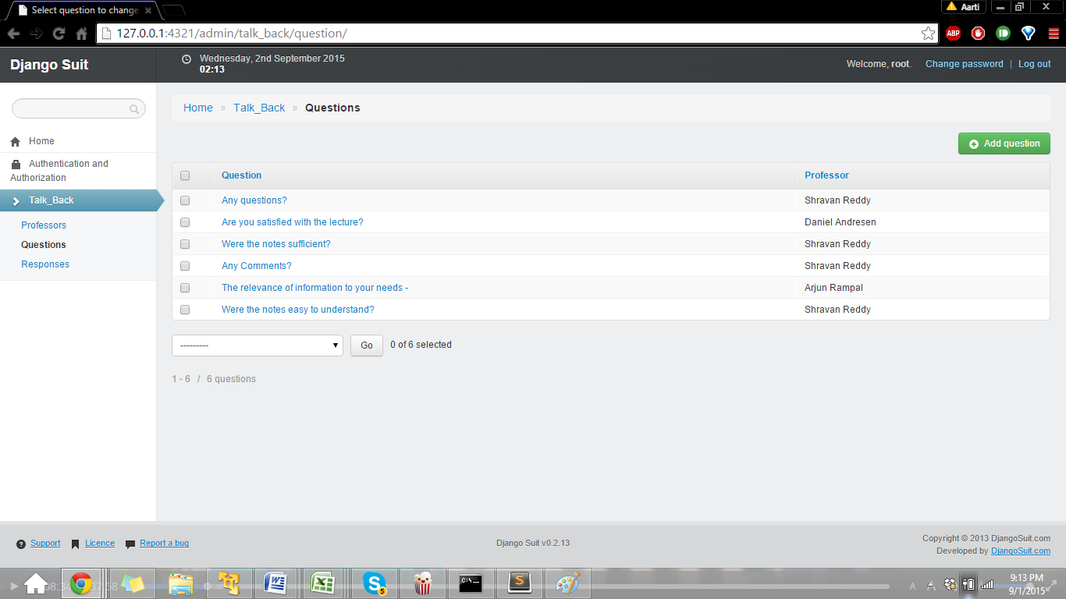

**Android Application**

**Questions View**

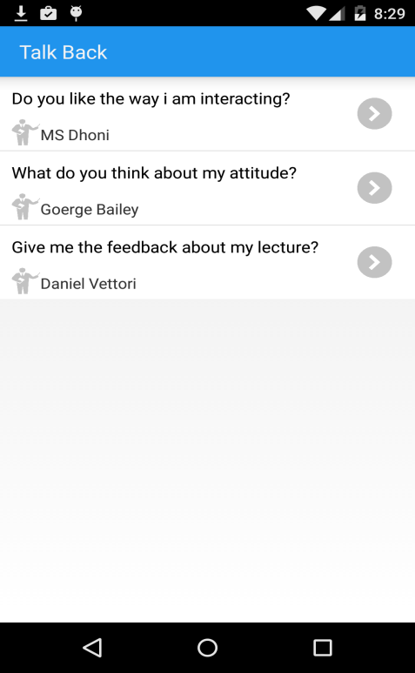

**Sending Responses**

**1. Yes/No Questions:**

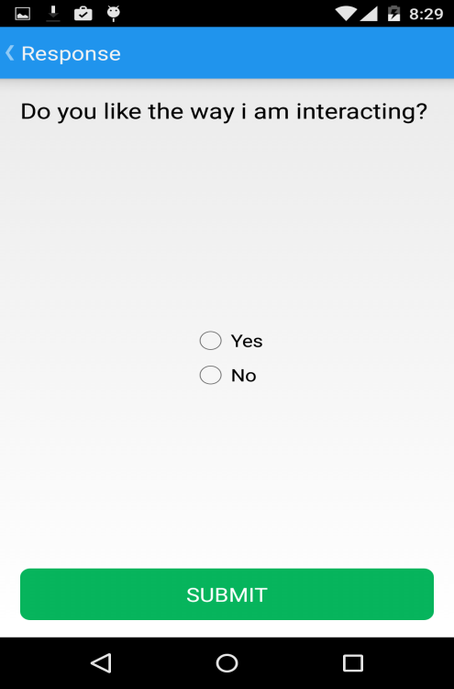

**2. Multiple Choice Questions:**

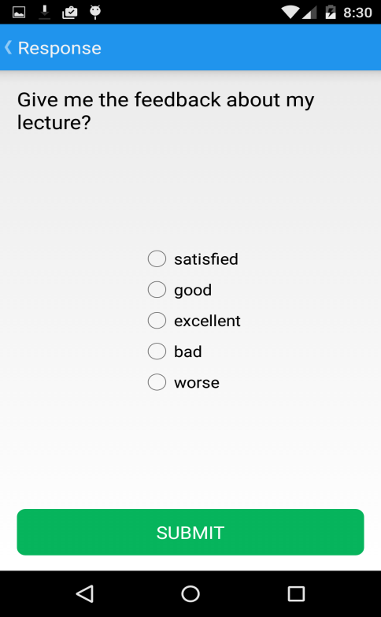

**3. Descriptive Text Questions:**

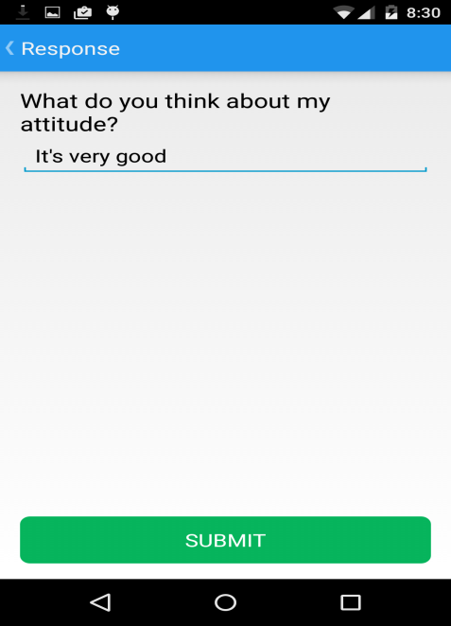

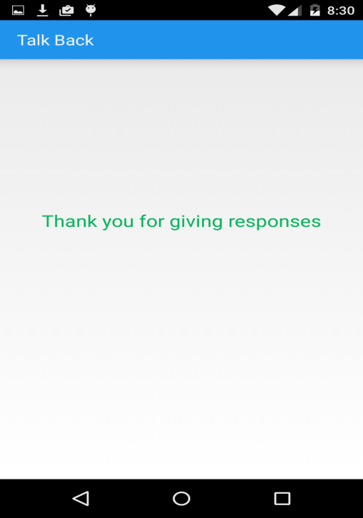

**Responses Table**

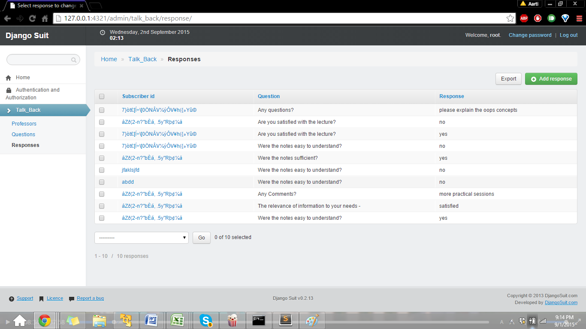

**Analytics/Visualization of Data**

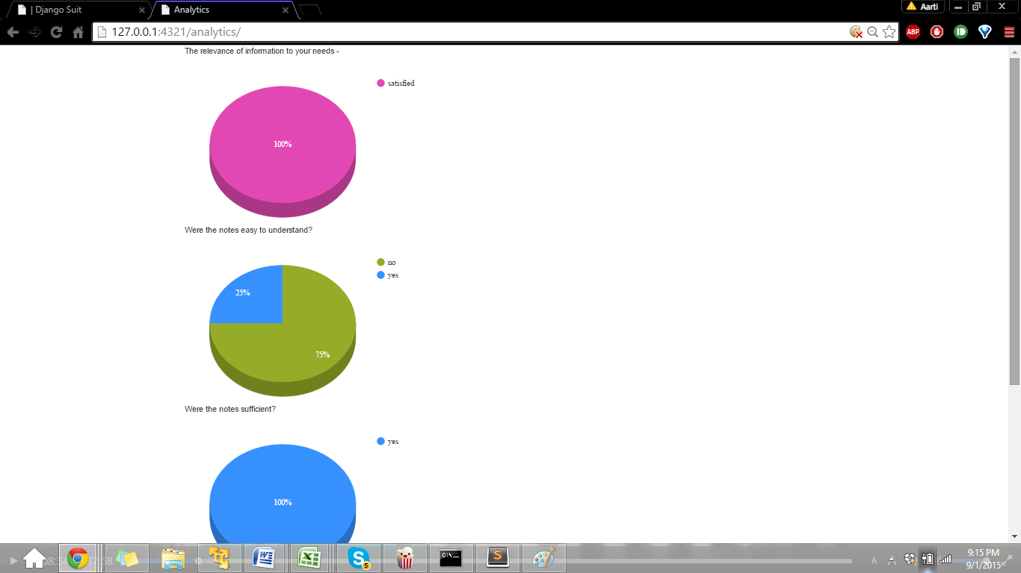

**Downloading the Response_table**

**Options for Downloading:**

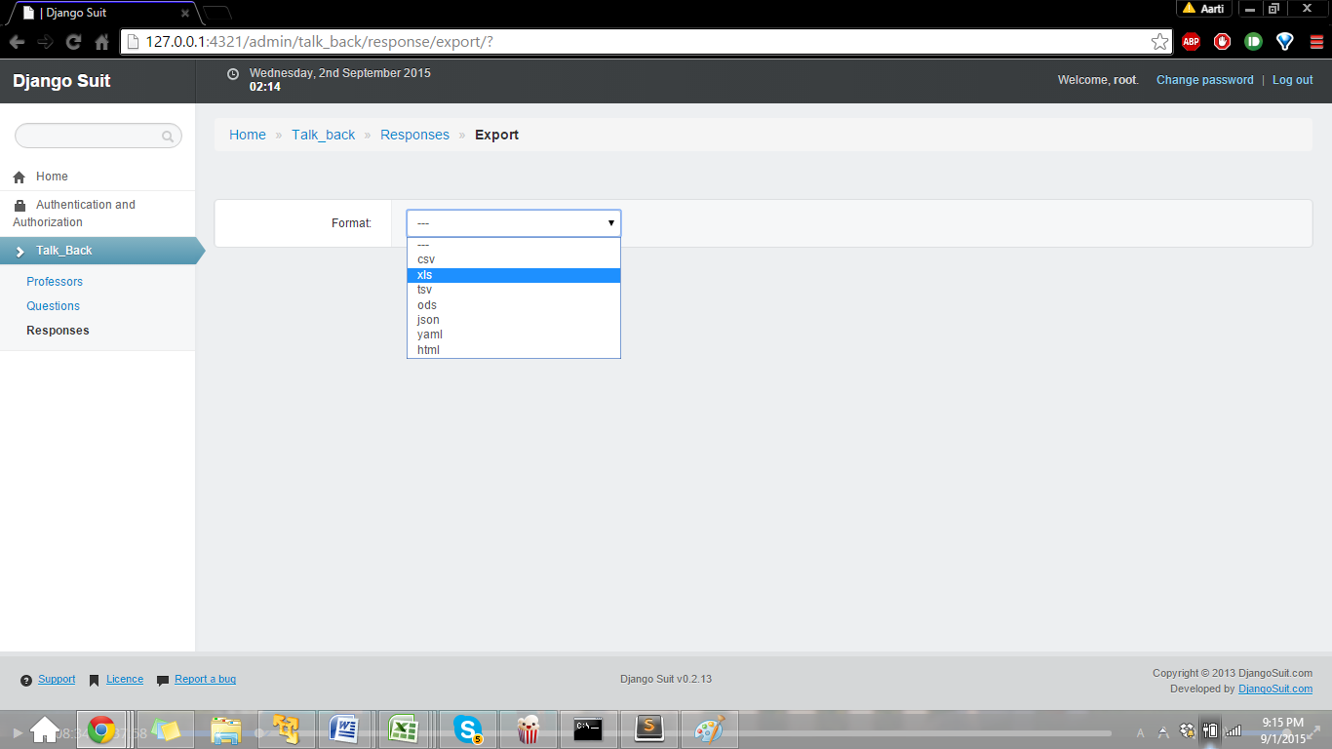

**Downloaded Excel sheet:**

